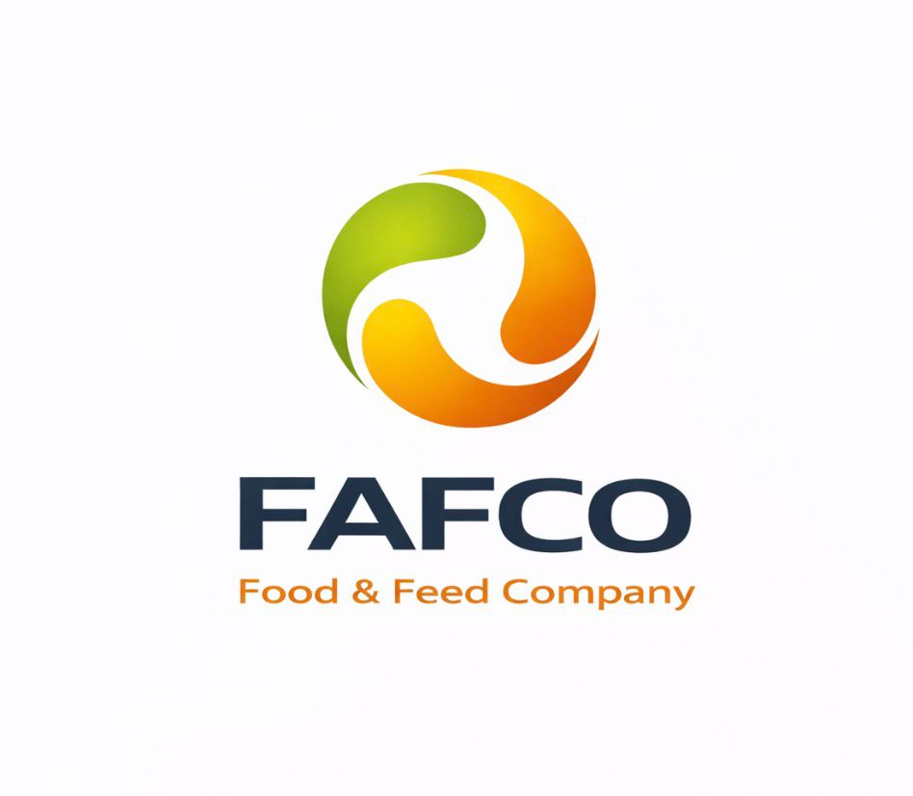
Reliable Supply of Food, Feed and Agricultural Commodities
We provide consistent supply from trusted producers, supported by full logistics coordination — from origin to final destination.
FAF Trading is an international trading company operating across Canada, Europe, and Eastern Europe, with growing partnerships in the Middle East, Asia, and Latin America.
The company is also expanding its presence in the United States market.

We specialize in B2B supply of food products, feed materials, and agricultural commodities.

Key Advantages:
- Direct sourcing from producers
- Quality control and compliance with standards
- Flexible delivery terms (FOB / CIF / EXW)
- Strong expertise in international logistics
- Experience with both containerized and bulk shipments
ABOUT US
FAF Trading is an international B2B trading company focused on the supply of food products, feed materials, and agricultural commodities.
The company is built on hands-on experience in agriculture, logistics, and international trade. We understand the full supply chain — from production and storage to transportation and final delivery.
Our goal is to provide reliable supply, transparent terms, and long-term partnerships.
We work with partners across Canada, Europe, and Eastern Europe, offering flexible solutions tailored to each client’s needs.
PRODUCTS
IMPORT
FOOD PRODUCTS
• Sugar
• Salt
• Rice
• Oils (sunflower oil, soybean oil, olive oil)
• Flour & Bakery Products
- wheat flour
- rusks & dry bread
- bakery products
• Grains & Cereals
- buckwheat
- pearl barley
- other cereals (on request)
• Canned & Preserved Vegetables
- pickled cucumbers
- canned tomatoes
- vegetable mixes & appetizers (lecho, salads, spreads)
• Honey, Jams & Nuts
- natural honey
- fruit jams & preserves
- nuts (almonds, hazelnuts, mixes)
• Fresh Fruits
- bananas
- oranges
- mandarins/clementines
- seasonal fruits (on request)
• Fresh Fruits
- bananas
- oranges
- mandarins/clementines
- seasonal fruits (on request)
• Juices & Drinks
- fruit juices
- carbonated drinks
- vitamin/functional drinks
- protein drinks

FEED PRODUCTS
• Soybean cake
• Sunflower meal (cake)
• Feed Grains
• Custom Feed Blends
- tailored formulations based on client requirements
- solutions for livestock and poultry sectors
• Feed-Grade Oils & Fats
- animal fat (tallow)
- poultry fat
- vegetable oils

We supply feed ingredients, energy components (oil&fats), and custom feed blends tailored to customer specifications.

EXPORT

Export Products

Agricultural Commodities:
- Canola oil
- Lentils
- Peas
Special Crops:
- Hops
Industrial & Wood Products:
- Lumber
- Wood pellets
- Logs
- Wood pulp (BSKP/BHKP)
Fertilizers & Crop Nutrition:
- Fertilizers (potash, nitrogen, phosphate)
- Compound Fertilizers (custom fertilizer blends)
We supply a wide range of fertilizers and crop nutrion products from Canada, including potash, nitrogen, and phosphate fertilizers.
We also offer custom NPK blends tairoled to specific soil and crop requirements.

LOGISTICS / SUPPLY CHAIN
We provide full-cycle supply chain management:
- Sourcing directly from producers
- Quality control and documentation
- Storage and cargo consolidation
- Transportation (truck / sea)
- Delivery to final destination
We work with reliable international logistics partners and ensure transparency at every stage of the supply process.

SUPPLY CAPABILITIES
We offer:
- Tailored solutions for each client
- Contract-based supply
- Flexible volumes
- Product sourcing based on client requirements
- Long-term partnership opportunities

Food Products
- Sugar
- Salt (1 kg / 25 kg)
- Rice
- Vegetable oils (sunflower, soybean, olive oil)
- Wheat flour

Additional Food Products (on request)
- Bakery products
- Cereals (buckwheat, pearl barley, others)
- Canned and preserved vegetables
- Honey, jams, and nuts
- Fresh fruits (seasonal)
- Juices and beverages

Feed Products
- Soybean meal / soybean cake
- Sunflower meal
- Feed grains
- Custom feed blends (based on client requirements)
- Feed-grade oils and fats (animal fat, poultry fat, vegetable oils)

Export Products
We supply export-oriented commodities from Canada and international markets, including:
Agricultural Commodities:
- Canola oil
- Lentils
- Peas
Special Crops:
- Hops
Industrial & Wood Products:
- Lumber
- Wood pellets
- Logs
- Wood pulp (BSKP / BHKP)
Fertilizers & Crop Nutrition:
- Potash, nitrogen, and phosphate fertilizers
- Compound fertilizers (custom NPK blends tailored to soil and crop requirements)

